ShopNest Store Sales Performance Insights

1. **Top Categories by Total Price:**
   * Identify and visually represent the top 10 product categories by total sales.

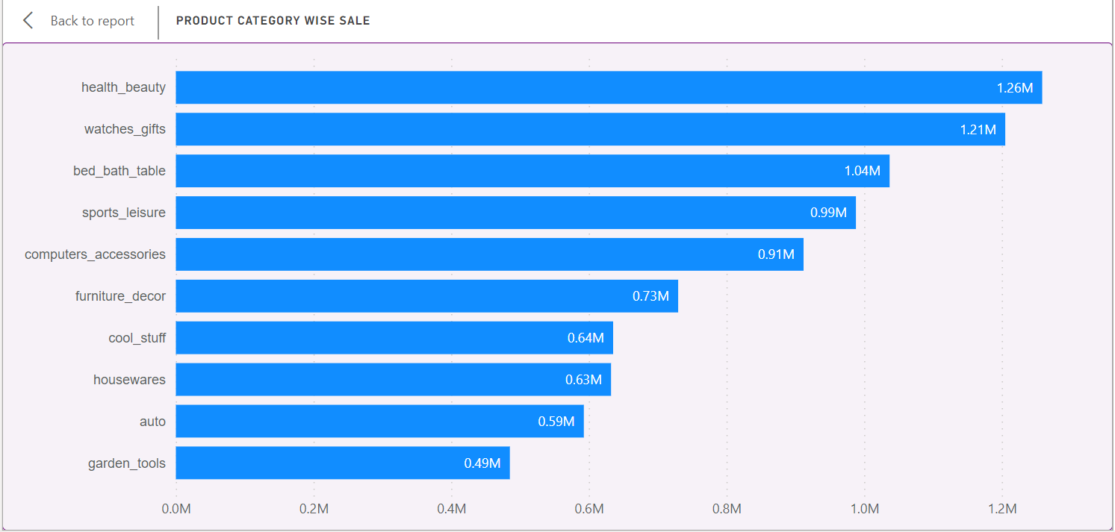

From above chart, it can be seen that, with respect to Total Sales, Top 10 Product Categories are health_beauty, watches_gifts, bed_bath_table, etc. Mainly we can notice that household items have occupied the major portion of total sales. This might be because, such items are mainly preferred for a gift. So, this might have increased sales against these items in particular.

This approach has given a clear visualization of which categories generate the most revenue, helping identify key areas of focus for strategic planning & operational adjustments.

Analysis of top-selling categories can inform inventory management decisions, helping to optimize stock levels and reduce inventory costs by focusing on high-demand products.

Insights into the sales performance of different categories can guide pricing strategies. Businesses can identify opportunities for premium pricing in high-performing categories or adjust prices in categories that are underperforming to boost sales.

Analyzing sales data by category can offer insights into customer purchasing behavior, preferences, and trends. This information is valuable for tailoring marketing messages, creating targeted promotions, and improving customer experiences.

Comparing top sales categories with competitors can help identify areas of competitive advantage or areas where improvements are needed to capture market share.

1. **Delayed Orders Analysis:**
   * Determine the number of delayed orders in each category. An order is considered delayed if the actual delivery date is later than the estimated delivery date.

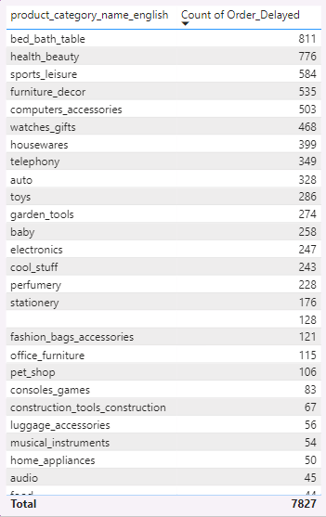

When we analyze the delayed orders count, it can be seen that, bed_bath_table, health_beauty, sports_leisure, etc. are some of the topmost product categories where the order delays can be seen.

In fact, many of the product categories mentioned besides share their portion in top selling category.

So, it can be said that, these are some of the categories which have proportionately higher sale and so the delays are proportionately more.

Amongst the total ~100K orders, around 7.8K orders got delayed, which means that the actual delivery date is later than the estimated delivery date.

So, the bifurcation of those 7.8K orders has been shown in the beside.

1. **Monthly Comparison of Delayed and On-Time Orders:**
   * Create a dynamic visual that compares the number of delayed orders to the number of orders received earlier for each month. Utilize the drillthrough cross-report feature to provide a detailed analysis of late and on-time deliveries.

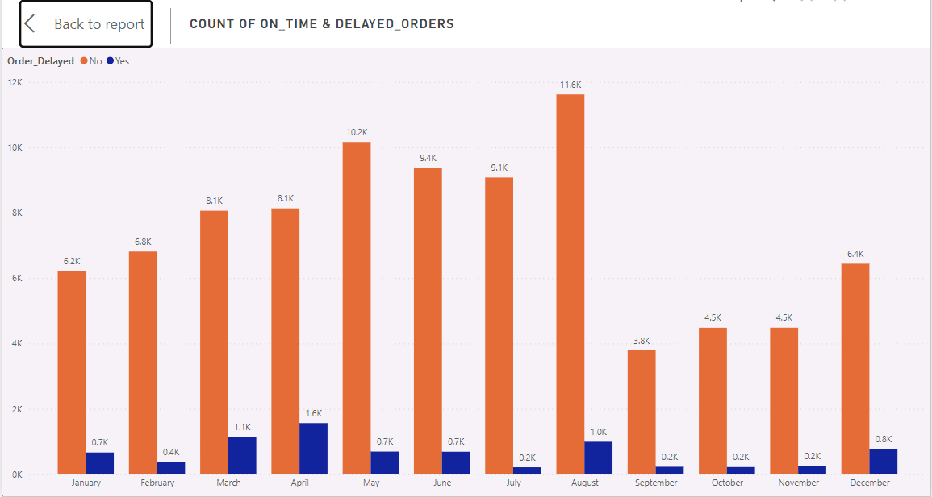

Above chart, shows the count of on time & delayed deliveries differentiated on monthly basis.

August month has highest count of on time deliveries of orders, whereas April month has highest count of delayed deliveries of orders.

In March & April months, Portugal hosts the Carnival Festival which can be linked to the above average sales of goods but might result into shortage of manpower to take care of the logistics part too. So this might have led to the delayed orders count being highest in these two months. There could be included supplier issues, logistics challenges, or internal processing delays also.

So, this shortcoming can be worked upon to achieve smooth operations & to achieve on time deliveries throughout the year & different seasons.

1. **Payment Method Analysis:**
   * Analyze the most frequently used payment methods by customers using a visually appealing representation, such as a pie chart or other suitable visuals.

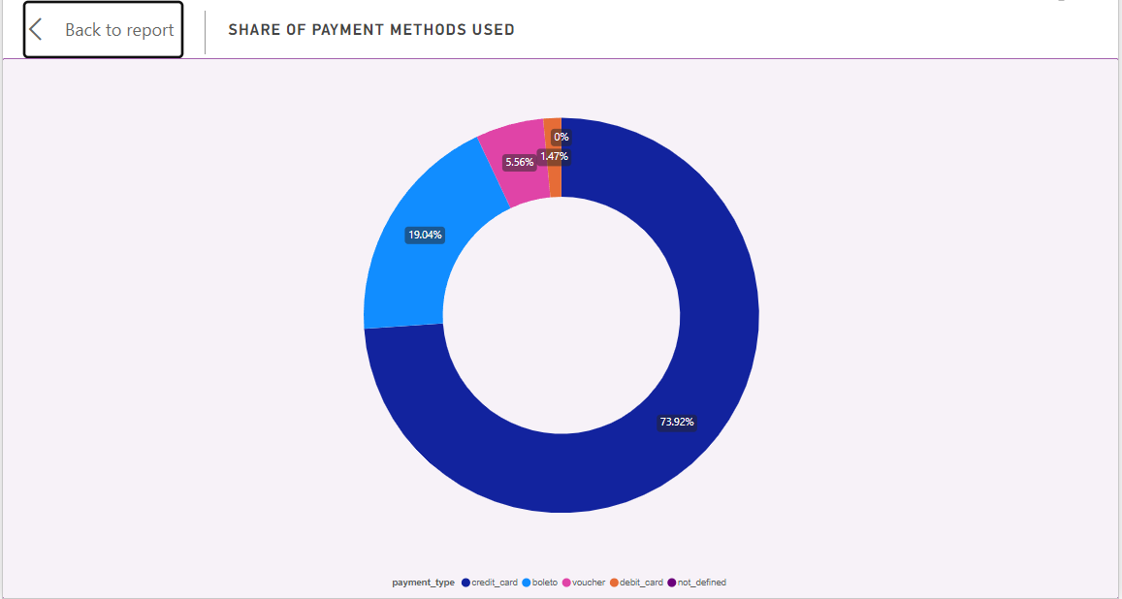

The most frequently used payment method by customers is Credit Card, which holds ~74% of the total share of payment methods used by the customers.

Credit card has become the predominant mode of payment on e-commerce platforms, favored by customers for their convenience, security, and the range of benefits they offer. The seamless integration of credit card payment systems allows for instant transactions, making the purchase process smoother and faster.

Additionally, credit card offers various rewards, cashback options & promotional discounts, incentivizing customers to use them even more.

So, this is evident to have Credit Card as the Topmost used payment method.

Second most used payment method is Boleto. Boleto is known for its user-friendliness and its adaptability to different payment scenarios. It enables customers to complete transactions by receiving a voucher indicating the amount to be paid for services or goods. The payment for the Boleto must be made before its expiration date through various means such as authorized agencies or banks, ATMs, or online. So the ease of payment makes it a second most used payment method.

1. **Product Rating Analysis:**
   * Determine the top 10 highest-rated products and the bottom 10 lowest-rated products using a bar or column chart.

Above chart shows the Top10 Highest Rated Product Categories (average), where we can see the CDs_DVDs_musicals category has highest rating of 4.67 out of 5 star ratings. Which indicates that, the items in this category are perfectly packed and gets delivered to customers in a good condition, so the customers have given highest rating to this category. Other top rated categories includes children fashion clothing, books, foods_drinks, etc. & bottom rated categories include security_&_services, office_furniture, etc.

1. **State-wise Sales Analysis:**
   * Identify and visually represent states with high and low sales, providing a clear understanding of regional sales performance.

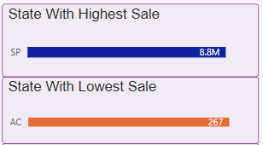

The state with highest sale reported as per our dataset is State of Sao Paolo, Brazil. Sao Paolo is the largest city in Brazil, which makes is evident that this city has more no. of transactions, shopping, business taking place as compared to the other cities.

The state with lowest sale reported is Acre state in Brazil. Only one city named as ‘Rio Branco’ is said to have set up business under ShopNest from the state for Acre. So, this makes it the state with lowest sale reported.

1. **Seasonal Sales Patterns:**
   * Investigate and visualize any seasonal patterns (Quarterly) or trends in sales data over the course of the year.

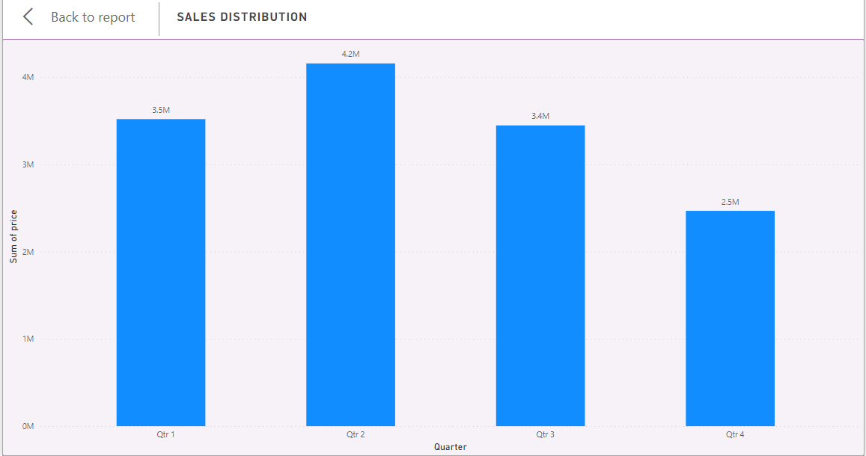

Above chart shows the distribution of sale over the year on quarterly basis.

We can notice that 2nd quarter has more sale as compared to other quarters, which can be linked to the Spring season & different festivals that are hosted during Mar to May months. These sales can be observed as being decreased as we move ahead in the year.

1. **Revenue Analysis:**
   * Determine the total revenue generated by ShopNest Store and analyze how it changes over time (Yearly). Represent this information through suitable visuals to highlight trends and patterns.

If we analyze the revenue part, it can be seen that revenue of 2018 has been increased over the revenue of year 2017, which can be called as a Positive Trend which is very much important for any business for that matter.

Also, the revenue for year 2017 can be seen as increased on quarterly basis.